Experiment 1

1. Create a collection Student with the following attributes RollNo, Age, ContactNo, Email ID and Name
2. Insert Appropriate values.

Commands:

1. Use Student
2. db.student.insert({“RollNo”:10,”Age”:18,”ContactNo”:”9087654689”,”emailid”:”[abc@gmail.com](mailto:abc@gmail.com)”,”ABC”})

Output: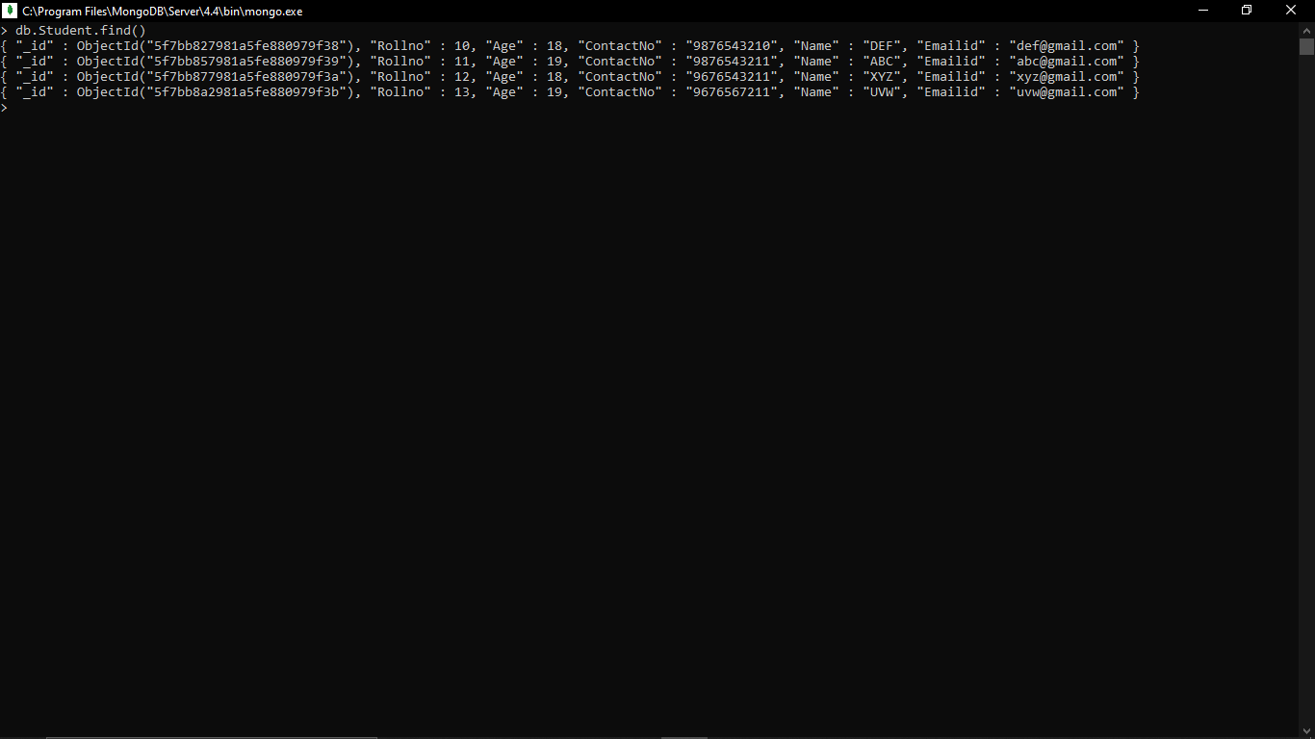

1. Write a query to update the email id of student whose roll number is 10

Command:

db.student.update({“Rollno”:10},{$set:{“Emailid”:[def@gmail.com](mailto:def@gmail.com)}})

Output:

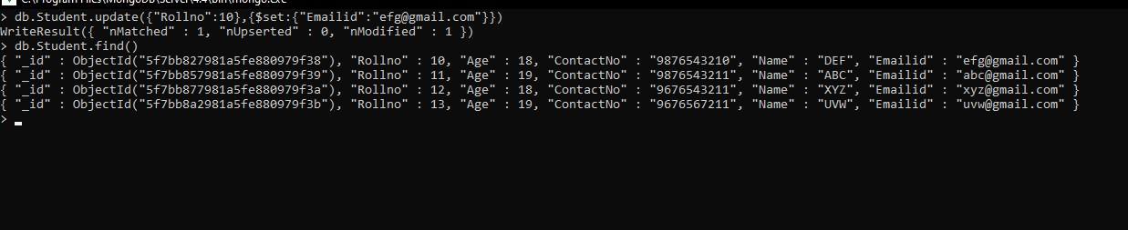

1. Replace the student name ABC TO FEM in roll number 11

Command:

db.student.update({“Rollno”:11,”Name”:”ABC”},{$set:{“Name”:”FEM”}})

Output:

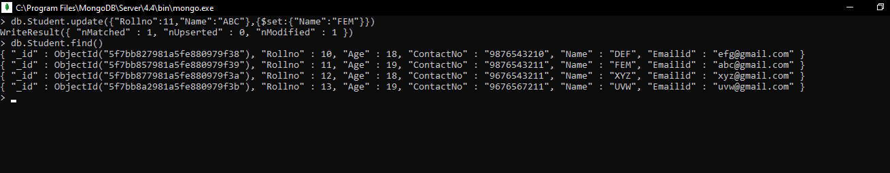

1. Export the created table into the local file system

Command:

Mongoexport –db Lab1 –collection Student –csv –fieldFile “d:/fields.txt” –out “d:/output.txt”

Output:

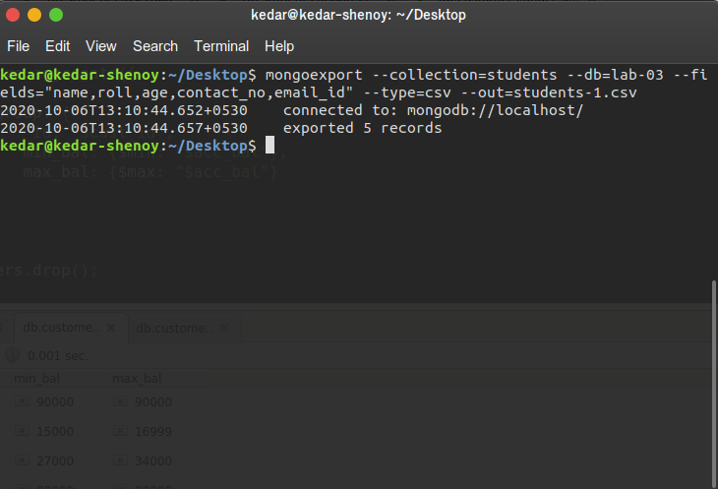

1. Drop the table

Command:

db.student.drop()

Output:

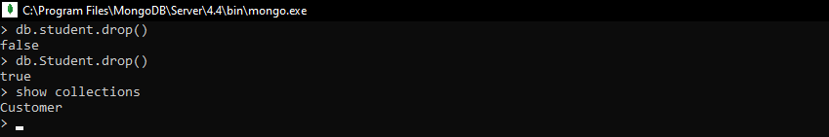

1. Import a csv dataset from local file into mongodb collection

Command:

Mongoimport –db Lab1 –collection=student –fields=”name,Rollno,Age,Contactno,Emailid” –type=csv –file=Student.csv

Output:

